SIMATS ENGINEERING

SAVEETHA INSTITUTE OF MEDICAL AND TECHNICAL SCIENCES

CHENNAI-602105

CSA0839 – PYTHON PROGRAMMING FOR CYBER SECURITY

Submitted By :S. Jaswanth Venkata Rahul

1)

def is_palindrome(s):

s = s.replace(" ", "").lower()

return s == s[::-1]

string = input("Enter a string: ")

if is_palindrome(string):

print("The string is a palindrome.")

else:

print("The string is not a palindrome.")

**Output:**

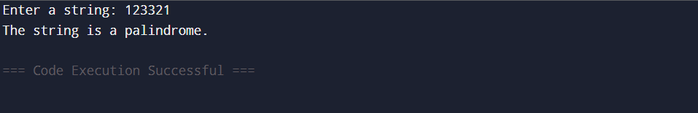

2)

sentence = input("Enter a sentence: ")

words = sentence.split()

word_count = {}

for word in words:

if word in word_count:

word_count[word] += 1

else:

word_count[word] = 1

for word in word_count:

print(word, ":", word_count[word])

Output:

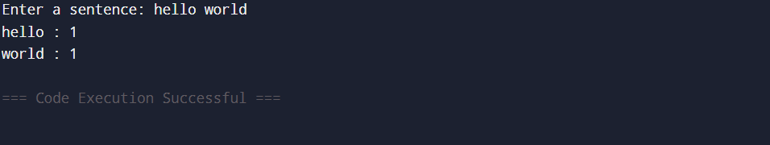

3)

text = input("Enter a string: ")

characters = len(text)

words = len(text.split())

lines = text.count('\n') + 1

print("Characters:", characters)

print("Words:", words)

print("Lines:", lines)

Output:

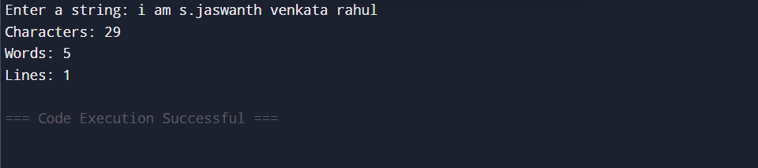

4)

sentences = ["I love Python", "This is simple", "Hello world"]

max_words = 0

for sentence in sentences:

words = sentence.split()

if len(words) > max_words:

max_words = len(words)

print("Maximum number of words in a sentence:", max_words)

Output:

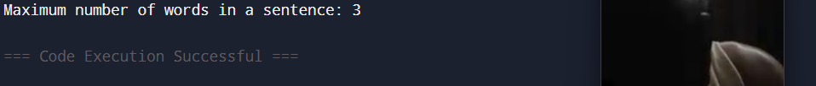

Test Case 1:

1.Input: sentences = ["alice and bob love apples", "i think so too", "this is great thanks very much"]

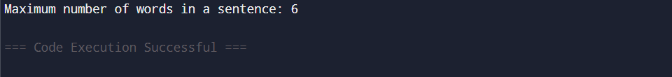

Test Case 2:

Input: sentences = ["Please wait", "Continue to fight", "Continue to win"]

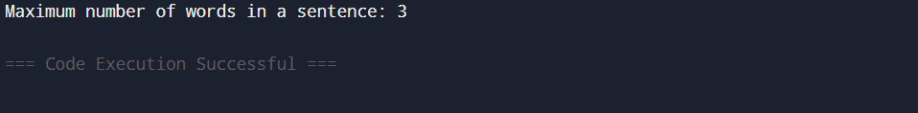

5)

x = int(input("Enter a number: "))

original = x

reverse = 0

while x > 0:

digit = x % 10

reverse = reverse * 10 + digit

x = x // 10

if original == reverse:

print(True)

else:

print(False)

Output:

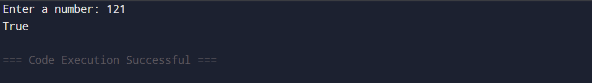

6)

inputs = list(map(int, input("Enter M, N, K separated by spaces: ").split()))

M = inputs[0]

N = inputs[1]

K = inputs[2]

for i in range(M, N + 1, K + 1):

print(i, end=" ")

Output:

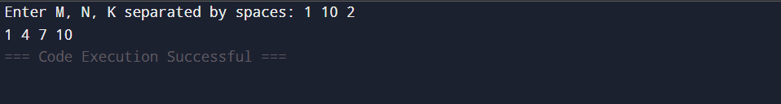

7)

year = int(input("Enter a year: "))

if year % 400 == 0:

print("Leap Year")

elif year % 100 == 0:

print("Not a Leap Year")

elif year % 4 == 0:

print("Leap Year")

else:

print("Not a Leap Year")

Ouyput:

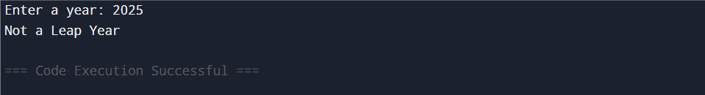

8)

rows = int(input("Number of rows: "))

for i in range(1, rows + 1):

for j in range(i, 0, -1):

print(j, end="")

print()

Output:

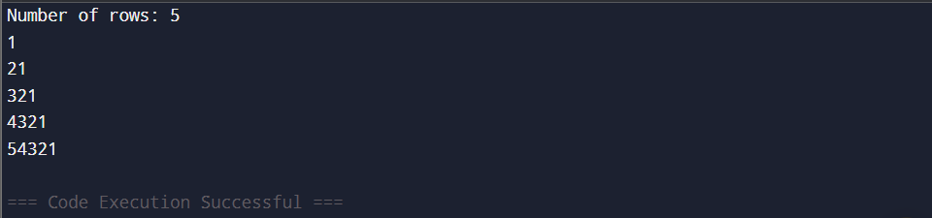

Test case 1: 6

